

| **Department of CYBER SECURITY** |
| --- |
| **PROJECT PROPOSAL** |

**Group ID**: (To be allocated by the Project Office)

| **Program:** | BS-CYBER SECURITY | **Session:** | 2024-2028 |
| --- | --- | --- | --- |
| **Semester:** | 1st | **Date:** | 09-Jan-2025 |

| **Project Title:** | **Tax bracket calculator** |
| --- | --- |
| **Department** | **Department of Electrical and Computer Engineering** |
| **Prsoject Abstract:**  This project is about making a simple program that calculates the tax a person has to pay based on their income. The program will use C++ and include basic programming concepts like loops and if-else conditions to figure out how much tax someone owes. It will also allow users to enter details about deductions like savings or medical expenses, and these will be subtracted to find the final taxable income.  The main purpose of this project is to practice programming basics while making something useful that helps people understand taxes easily.  **Keywords:**   * Tax Bracket Calculation * Deductions * Financial Computation * C++ Programming * Control Structures   **Introduction**  Tax calculations can be difficult and confusing, especially for someone who doesn’t know much about tax rules. This project is meant to make it simple. The Tax Bracket Calculator will ask the user to enter their annual income and details about any tax exemptions or deductions they can claim. Based on these inputs, the program will calculate the tax amount.  The goal is to create a small and easy-to-use program that runs directly in the console. It will not only calculate taxes but also help users understand how their income and deductions affect the final tax amount. This project is a practical way to learn and apply basic programming concepts like conditional statements, loops, and input/output handling. Problem Statement Paying taxes is something everyone has to do, but understanding tax brackets and calculating the exact amount can be tricky. People often make mistakes when calculating their taxes manually, and even small errors can lead to big issues.  The problem becomes worse when deductions like medical expenses or savings need to be applied, as people might not know how to adjust their taxable income. This project focuses on solving this problem by creating a simple program that calculates taxes accurately based on user inputs. It will also show how deductions can reduce taxable income. Problem Solution for Proposed System The Tax Bracket Calculator will help solve the problem by providing an easy and automated way to calculate taxes.   1. **Step 1: Income Input** The user will enter their total annual income. 2. **Step 2: Deductions Input** Users will be able to input amounts for things like medical expenses or investments, which the program will subtract from the income. 3. **Step 3: Tax Calculation** Based on the adjusted income, the program will figure out the correct tax bracket and calculate the tax owed using predefined rates. 4. **Step 4: Display Output** The program will show the final tax amount along with the details of the deductions applied.   This step-by-step process ensures accuracy and simplicity, making it easy even for people with no programming experience to use.    **Benefits**  This project has several benefits, both for learning programming and for practical use:   * **Learning Basic Programming:** The project is a great way to practice loops, conditions, and user input/output in C++. * **Simplifies Tax Calculation:** It removes the confusion of figuring out tax brackets manually. * **Encourages Logical Thinking:** Writing the program will help develop problem-solving skills by breaking a big task (tax calculation) into smaller, manageable steps. * **Provides Accurate Results:** By using formulas and rules for tax brackets, the program ensures there are no mistakes in the final calculation. * **Educational Value:** The program can be used as a learning tool for others to understand how tax brackets and deductions work.   **Tools / Technologies to be used:**  **C++ Programming Language** The entire program will be written in C++ using basic features like conditional statements, loops, and user input.  **File Handling (Optional):** For more advanced features, we might store tax brackets or user data in a file and read/write data during the program.  **Development Tools:**   * **Visual Studio** or **Dev-C++** IDE for coding and testing. * **MS Word** for documentation.   **Project Steps:**  **Gather Input:** The program will ask the user to enter their annual income and deductions.  **Identify Tax Bracket:** Using if-else or switch-case statements, the program will match the income to the correct tax bracket.  **Apply Deductions:** Deductions will be subtracted from the income to get the taxable income.  **Calculate Tax:** A formula will be applied to calculate the tax based on the adjusted income and tax rate.  **Show Output:** The program will display the tax owed and the details of deductions applied. | |

**Tax bracket calculator**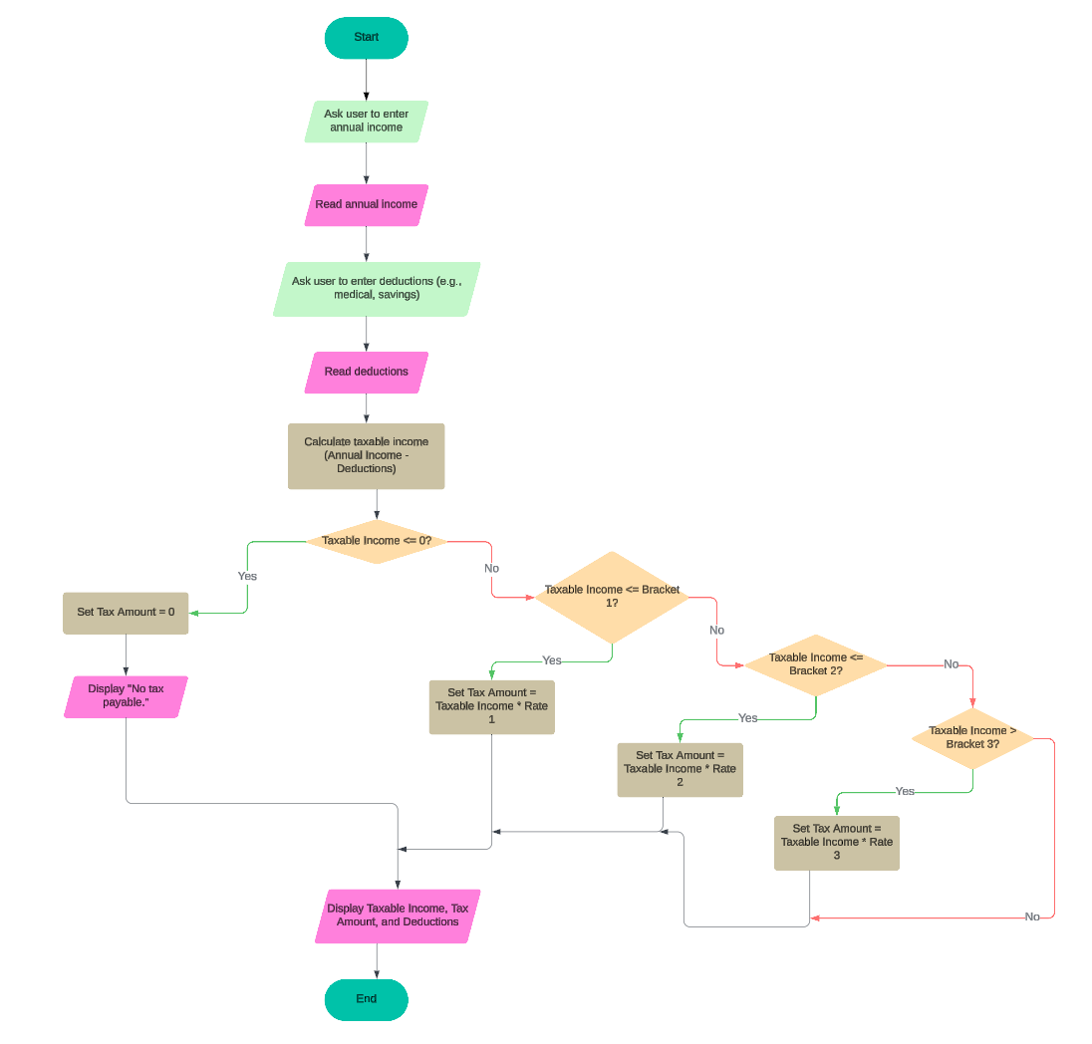

**STUDENT DETAILS**

| **Reg. #** | **Name** | **Email** | **Signature** |
| --- | --- | --- | --- |
| Bcy243041 | Yusra Farooq | bcy243041@cust.edu |  |

| **Remarks:** | **Signature and Date:** |
| --- | --- |



**(For Department use only)**

**Approved Group ID:**

**Meeting Required:**

**Date: _____________**

**Time:**

**Place:** 

**If Rejected**

| **Remarks:** |
| --- |
| **Project Title (If revised):** |

**Coordinator**

| **Approved: YES NO** | **Department of Electrical and Computer Engineering** |
| --- | --- |